Test Case: tc006_SPX_Dev5_Crear_Requisicion_Spot_Tipo_Cobro_Proyect_Urgent
Step 1 - Enter username and password and click to button Enter: Credentials Entered
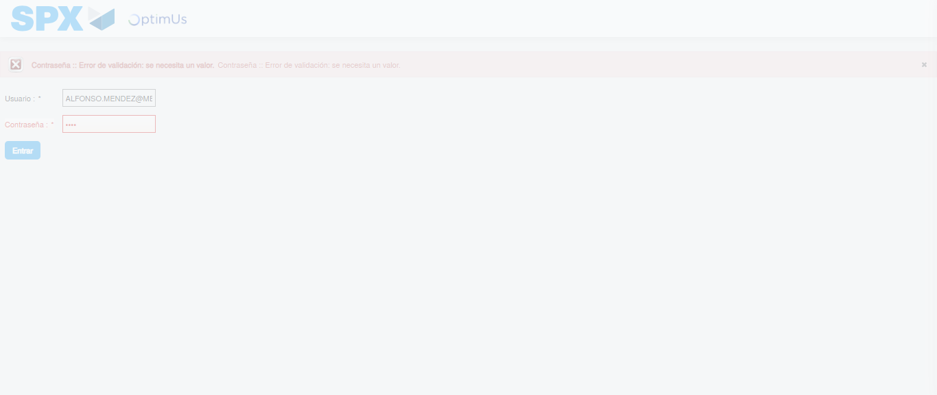Image file-name: QC_Testing-tc006_SPX_Dev5_Crear_Requisicion_Spot_Tipo_Cobro_Proyect_Urgent-1783379019915

Step 2 - Select to UEN and Access to Spot Buy Requisitions : UEN Correctly selected and Correct access
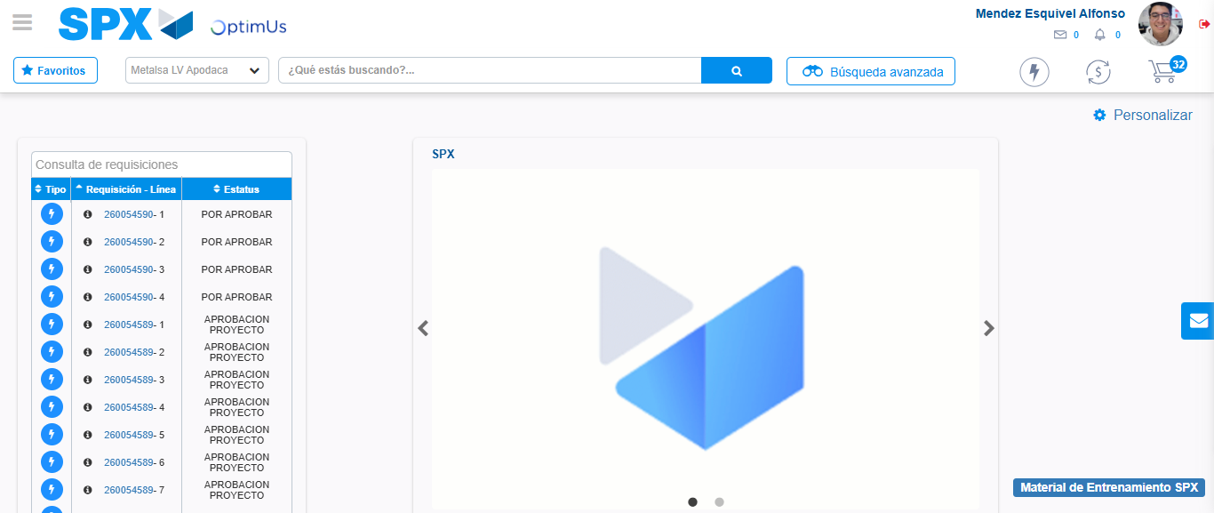Image file-name: QC_Testing-tc006_SPX_Dev5_Crear_Requisicion_Spot_Tipo_Cobro_Proyect_Urgent-1783379045997

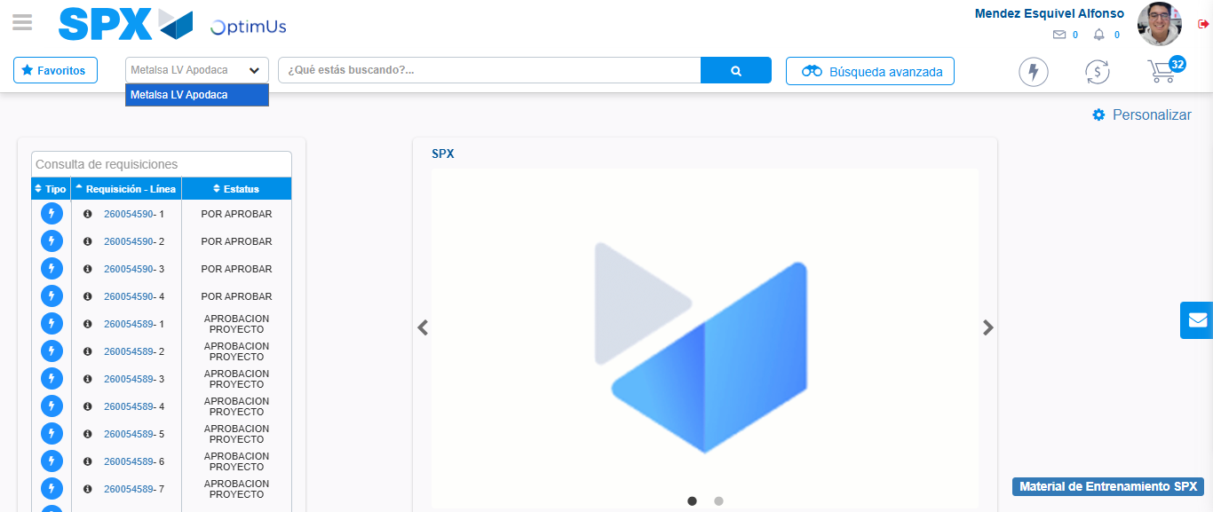Image file-name: QC_Testing-tc006_SPX_Dev5_Crear_Requisicion_Spot_Tipo_Cobro_Proyect_Urgent-1783379048553

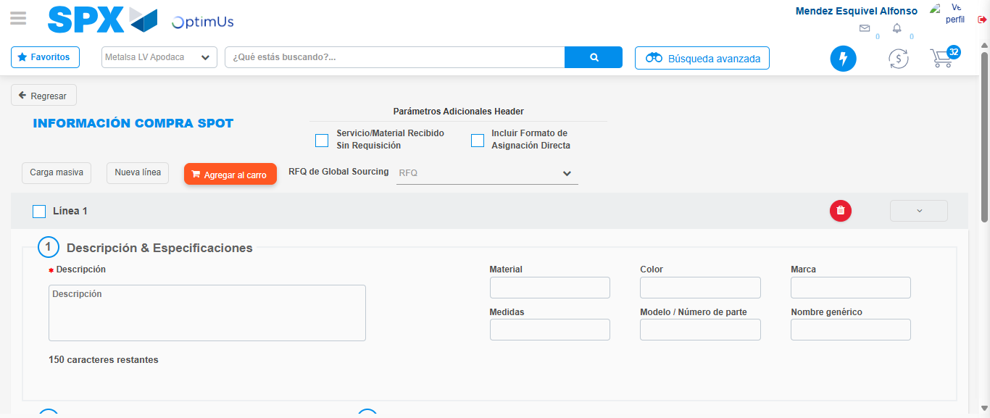Image file-name: QC_Testing-tc006_SPX_Dev5_Crear_Requisicion_Spot_Tipo_Cobro_Proyect_Urgent-1783379069128

Step 3 - Data Capture Spot Buy Requisition: Data captured correctly
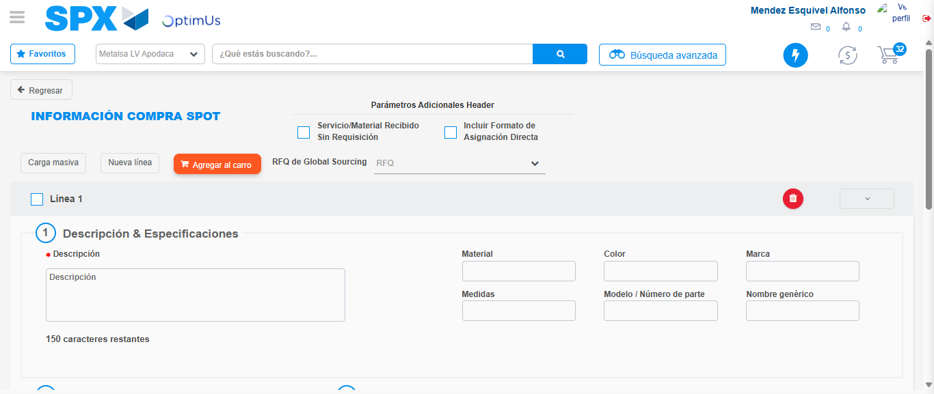Image file-name: QC_Testing-tc006_SPX_Dev5_Crear_Requisicion_Spot_Tipo_Cobro_Proyect_Urgent-1783379069394

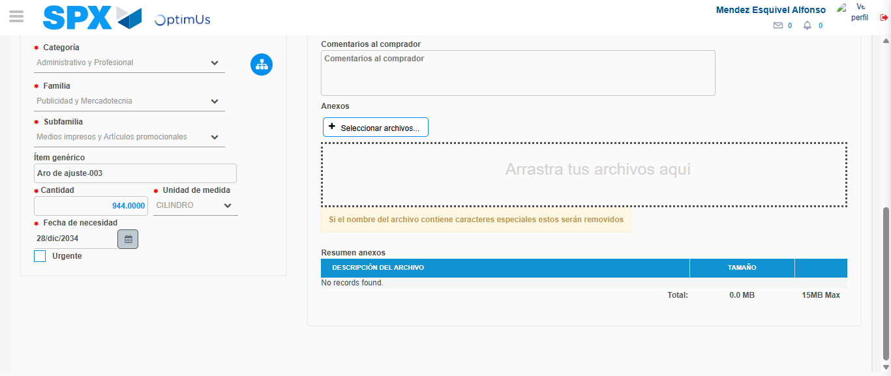Image file-name: QC_Testing-tc006_SPX_Dev5_Crear_Requisicion_Spot_Tipo_Cobro_Proyect_Urgent-1783379080296

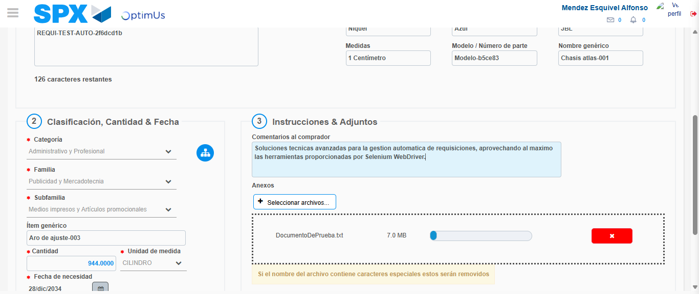Image file-name: QC_Testing-tc006_SPX_Dev5_Crear_Requisicion_Spot_Tipo_Cobro_Proyect_Urgent-1783379081072

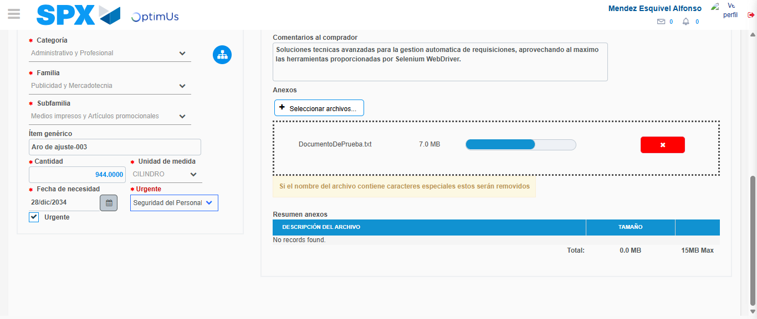Image file-name: QC_Testing-tc006_SPX_Dev5_Crear_Requisicion_Spot_Tipo_Cobro_Proyect_Urgent-1783379084721

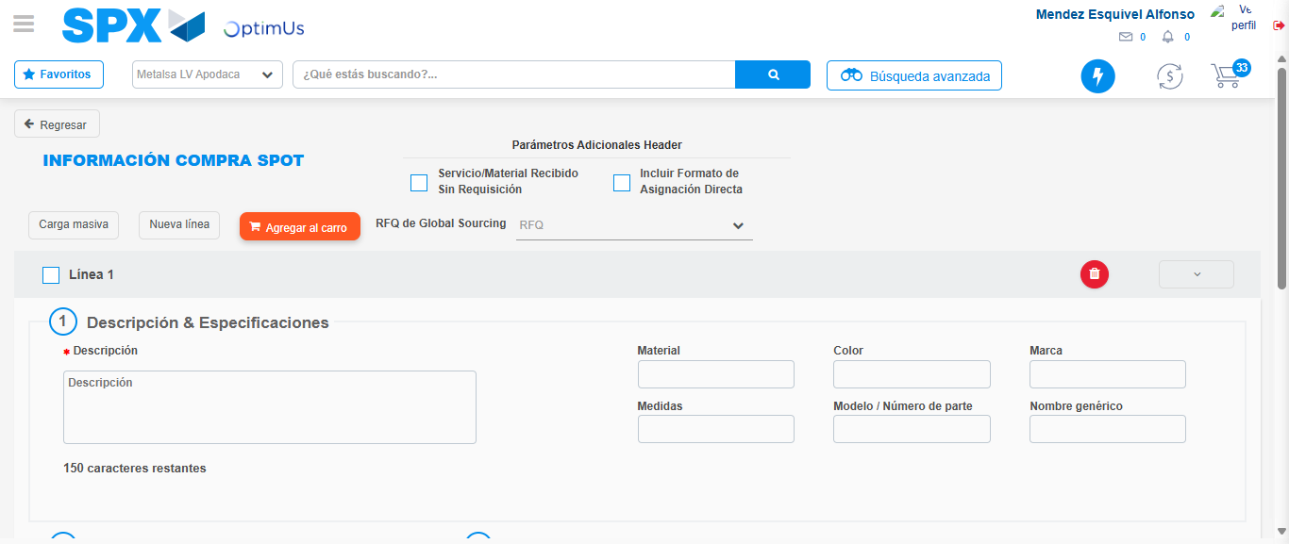Image file-name: QC_Testing-tc006_SPX_Dev5_Crear_Requisicion_Spot_Tipo_Cobro_Proyect_Urgent-1783379086131

Step 7 - Return to Main Page SPX : Return to Main Page SPX
Image file-name: QC_Testing-tc006_SPX_Dev5_Crear_Requisicion_Spot_Tipo_Cobro_Proyect_Urgent-1783379045997

Image file-name: QC_Testing-tc006_SPX_Dev5_Crear_Requisicion_Spot_Tipo_Cobro_Proyect_Urgent-1783379048553

Image file-name: QC_Testing-tc006_SPX_Dev5_Crear_Requisicion_Spot_Tipo_Cobro_Proyect_Urgent-1783379069128

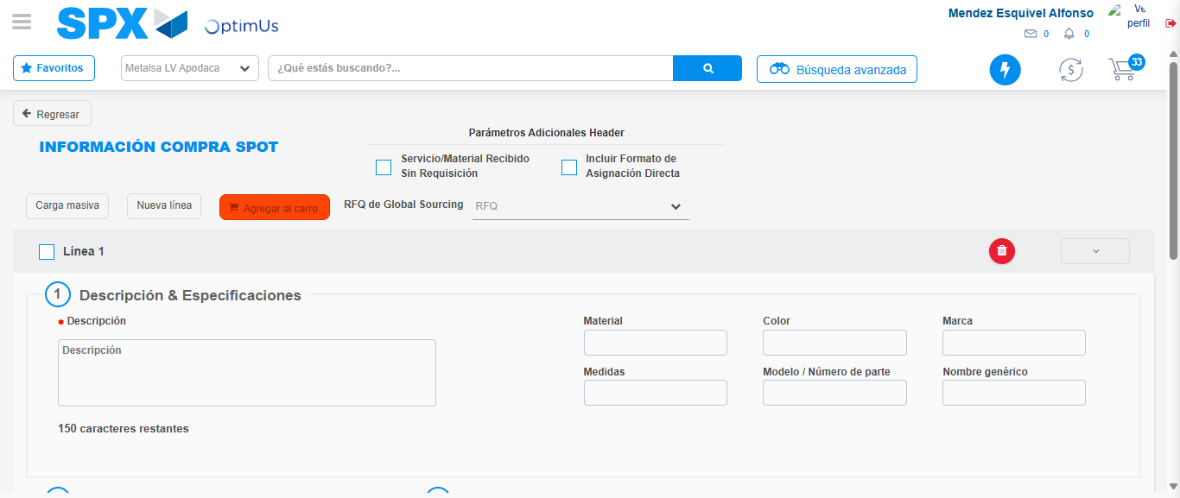Image file-name: QC_Testing-tc006_SPX_Dev5_Crear_Requisicion_Spot_Tipo_Cobro_Proyect_Urgent-1783379088361

Image file-name: QC_Testing-tc006_SPX_Dev5_Crear_Requisicion_Spot_Tipo_Cobro_Proyect_Urgent-1783379088543

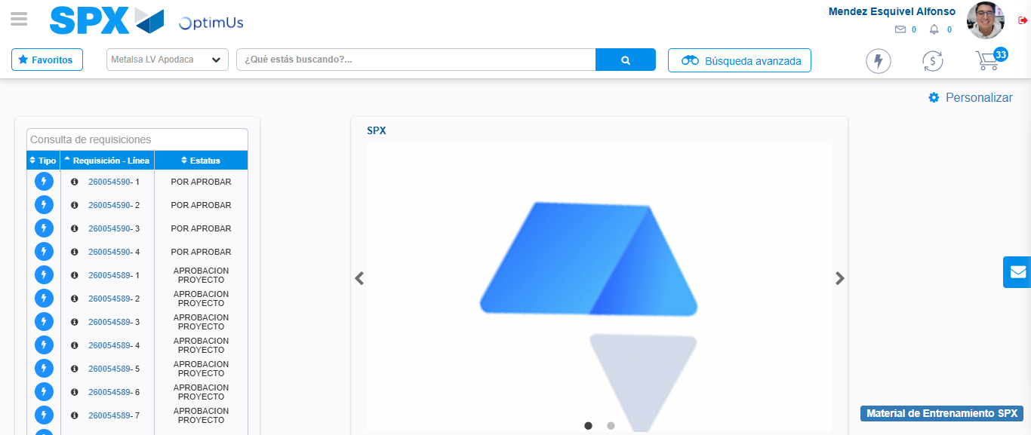Image file-name: QC_Testing-tc006_SPX_Dev5_Crear_Requisicion_Spot_Tipo_Cobro_Proyect_Urgent-1783379109664

Step 8 - Log Out : Log Out SPX
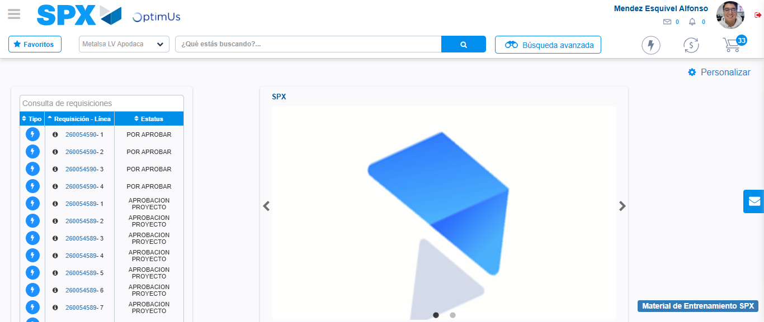Image file-name: QC_Testing-tc006_SPX_Dev5_Crear_Requisicion_Spot_Tipo_Cobro_Proyect_Urgent-1783379109883

